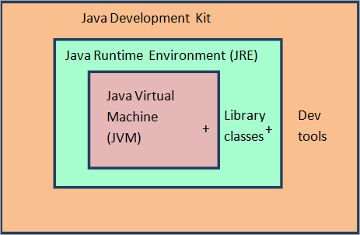**Java**

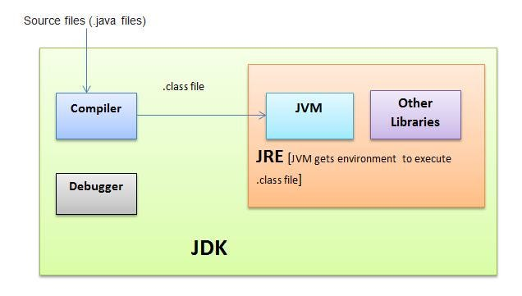

|  |  |  |  |  |  |
| --- | --- | --- | --- | --- | --- |
| **How it Works** | |  |  | public | All classes |
| Hardware | OS | JVM |  | private | Declared class |
| my code | bytecode | jvm |  | default | Same Package |
| .java -> | java compiler -> | .class |  | protected | [Same Package and Subclass](https://www.w3schools.com/java/java_inheritance.asp) |

|  |  |  |
| --- | --- | --- |
| **Java Language** | | |
| Portable | Multithreaded | High performance |
| Object-oriented | Architecture-neutral | Distributed |
| Robust | Interpreted | Dynamic |

|  |  |
| --- | --- |
| **Static (Belongs to Type)** | |
| Shared Memory, Access without instantiation, cant access non-static | |
| Blocks | Runs once do computation for variables |
| Variables | Single copy all classes |
| Methods | Access without creating class |
| Classes | For an inner nested class |

|  |  |  |
| --- | --- | --- |
| **OOP** | | |
| Inheritance | I do all the time | extends |
| Method Overloading | Same name but different inputs |  |
| Polymorphism | Child can override parent method |  |
|  | Interface Animal - Dog Horse Sound |  |

|  |  |  |
| --- | --- | --- |
|  | **Abstract Class** | **Interface** |
| Keyword | extends | implements |
|  | Cant be instantiated | Contract of methods to implement |
| Creating | A class can inherit from only one abstract class (It is a type of object) | Can implement multiple interfaces because it represents set of behaviors |
| Access | Public, Protected Private | Public |
| Variables | both | final |
| Benefits | avoid duplication | improve code readibilty |
|  |  | enforce design patterns |
| Methods | both | only abstract |

|  |  |
| --- | --- |
| **Version** | **Features** |
| **Java 8** | Lambdas, Collections and Streams |
| **Java 9** | Collections new helper methods (Easily make set, list Map) |
|  | Interfaces got private methods (sensitive code) |
|  | HTTP Client |
| **Java 10** | var detect type |
| **Java 11** | HTTP Client- finalized |
|  | Strings got methods is blank and strip |
| **Java 13** | Switch statements can return a value and lambda syntax |
| **Java 14** | standarized switch |
| **Java 15** | Strings in multiline |
| **Java 16** | Patterm matching for instance of |
| **Java 17 (LTS)** |  |
| **Java 18** | UTF-8 by default |
|  | Simple Web Server (jwebserver) |
| **Java 19** | virtual threads |
| **Java 20** |  |